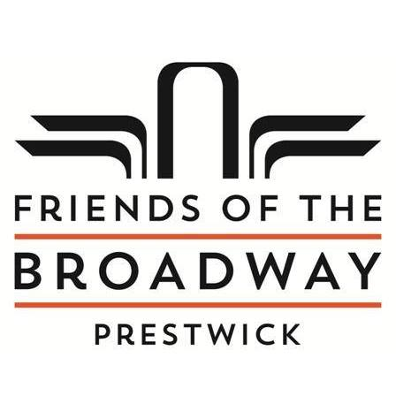

Company Number: SC618864

PROXY VOTING FORM

Member Name(s):

Member Address:

I give _________________________________________ authorisation to vote on my behalf on all issues put to a vote by the Friends of the Broadway Prestwick during the Annual General Meeting on Friday 30th August 2024.

Member(s) Signature:

Date: